**ASSIGNMENT-14**

**Ques 1: Explain the below DockerFile**

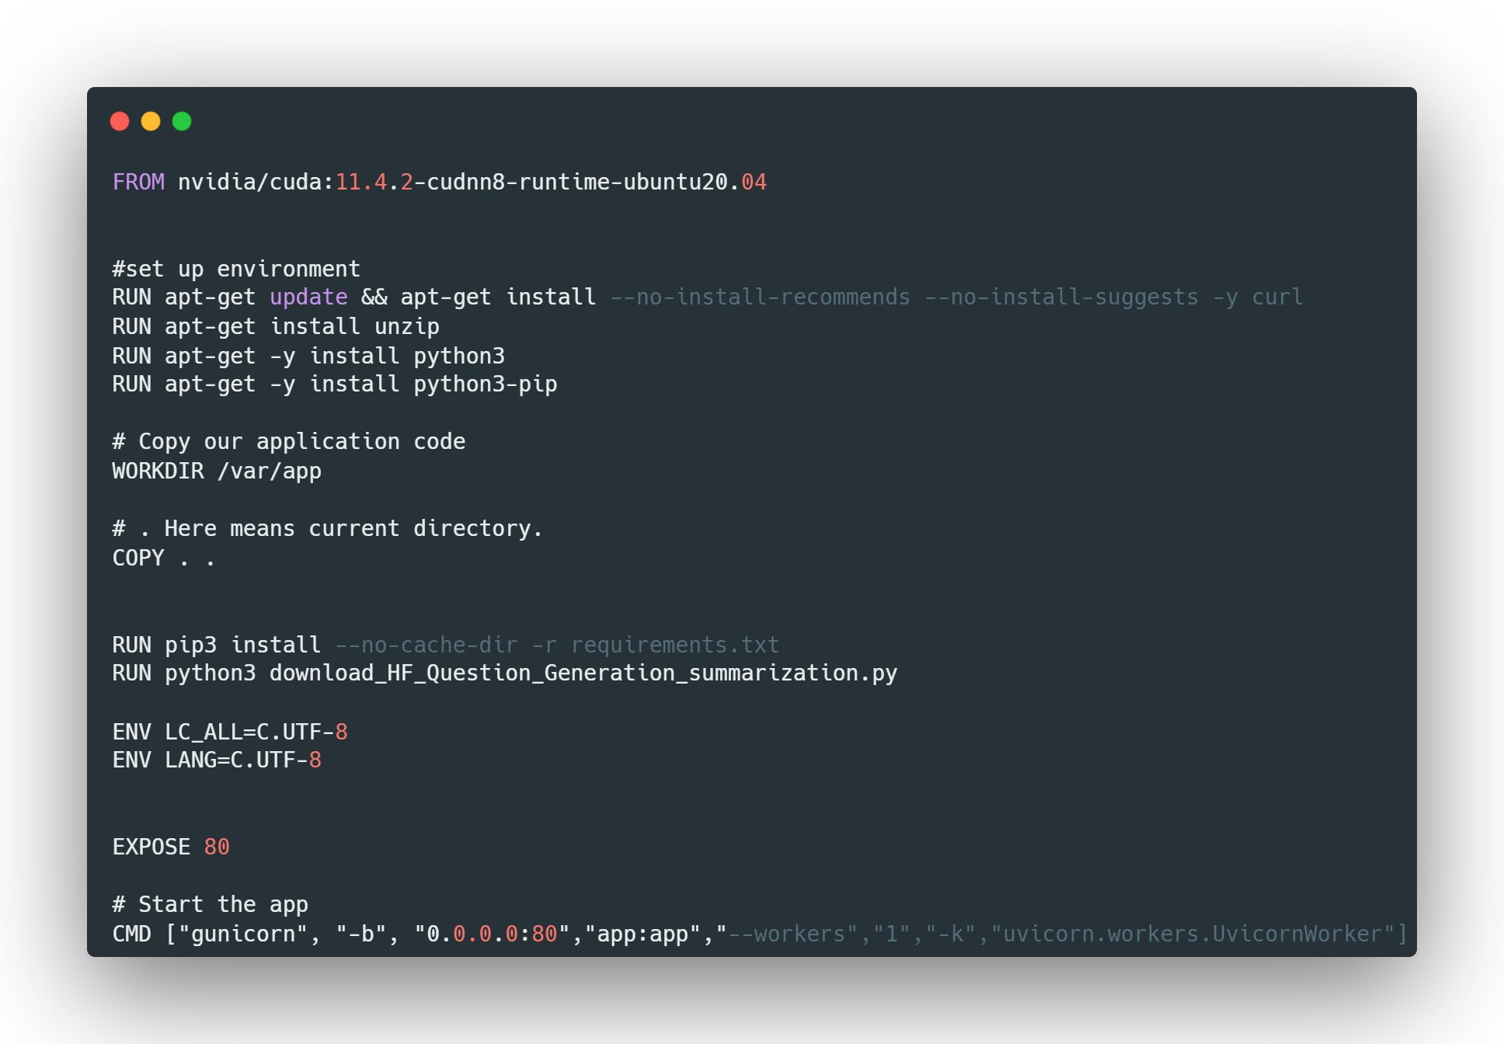

**Explanation:**

In the first line, we are using **FROM** command for setting the base image with **ubuntu OS** with a particular version. Then in the next four lines, we are updating and installing the necessary packages using the ubuntu package manager which is **apt-get**. We are updating the package manager and installing the package manager, unzip, python3 and python3-pip. Next, we are setting the working directory path. Using the command **WORKDIR**, then we are copying the files in the current directory to the working directory. Then we are installing pip3 and we are running the command python3 with file_name.py as our first file to be executed when running the application. We are setting the environment variable for the application using **ENV**. Which **LC_ALL** and **LANG**. We are using the **EXPOSE** command the expose our application to the outside world in port no 80. **CMD** command is the first command to start the app. And we are mentioning the port no in the command.